T-2D Brushless Gibmal Additional Remarks 2013-6-28
Controller interface and connection introdution：

1.Gimbal controller connector：Via USB module connected to the computer. When you use this USB Module at first time , please intall its dirver.
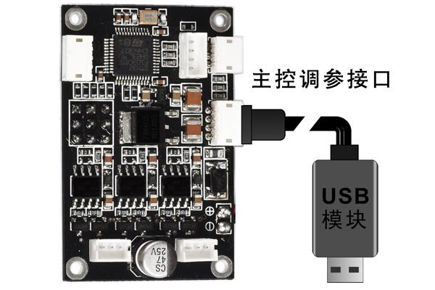

2.Motor driver connector: Via USB module connected to the computer for setting motor parameters.

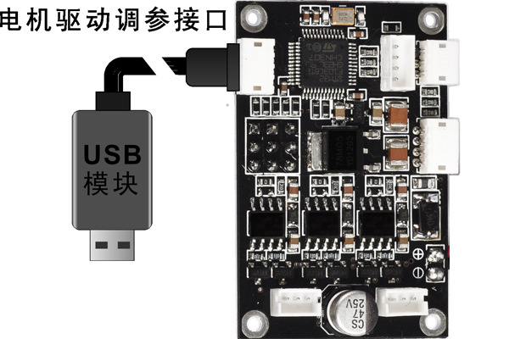

3.Connected with independent conventional receiver: users can select Mode/Tilt/Roll input channel connect to conventional receiver, and make sure power ground connection rightly.
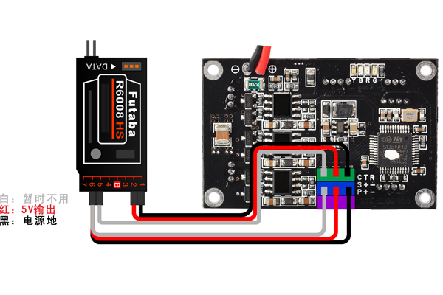
4.Connected with flight controller receiver: users can select Mode/Tilt/Roll input channel connect to conventional receiver, and make sure power ground connection rightly, but do not connect the 5V output wire.
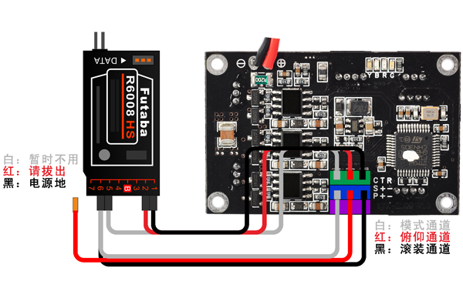

5.SBUS receiver:
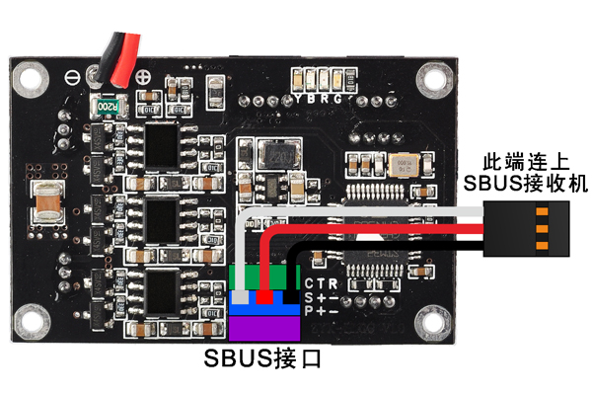

6.DSM2/DSMJ/DSMX receiver type：
DSM2-1：Transmitter is DX7 etc. (binding by 6 or 7 channels receiver)
DSM2-2：Transmitter is DX8, DSX9 etc. (binding by 6 or 7 channels receiver)
DSM2-3：Transmitter is DX8, DSX9 etc. (binding by 9 channels receiver)
DSM2-4：Transmitter is DM8, DM9 module. (binding by 6 or 7 channels receiver)
DSMJ： Transmitter is DSMJ format. (Binding by matched receiver)
DSMX-1：Transmitter is DX 8 etc. (11ms mode, binding by matched receiver)
DSMX-2：Transmitter is DX 8 etc. (22ms mode, binding by matched receiv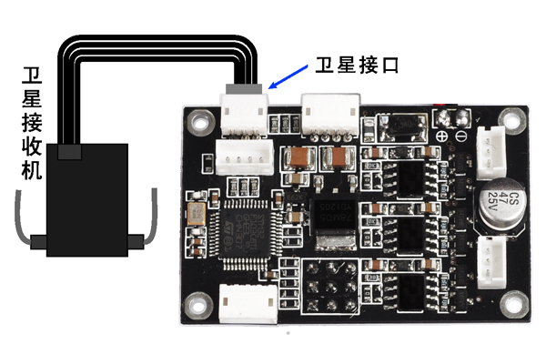
7.Sensor connecto:
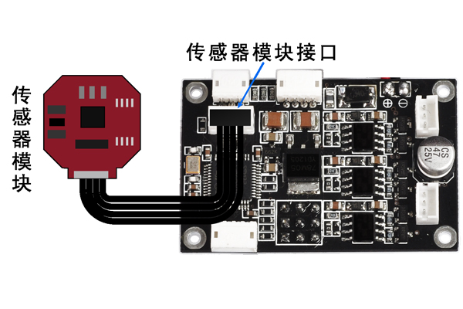
8. Connected with motors
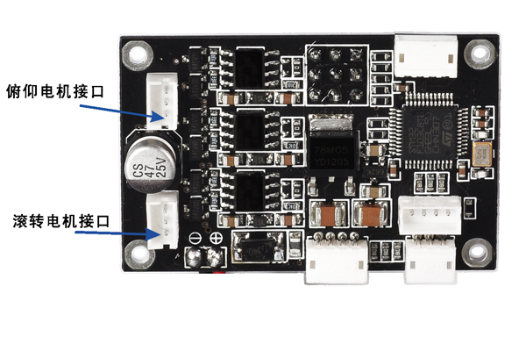

2.Intial tilting angle introdution:
The initial tilting angle of T-2D default factory setting is 0 degree. If you want to change the initial tilting angle when the gimbal restart, you could modify the init tilt angle parameter in PC software, and click’write setting to flash’.

